Faculty Finance Start Guide: Goods & Services

This document includes guidelines for faculty who are planning 1. purchases, 2. hiring for services (e.g., guest artists and speakers), 3. music rentals, or 4. music purchases for productions.

Faculty begin budget planning during the spring semester preceding the start of each fiscal year (July 1 to June 30) for their curricular needs with their respective Division Chairs (Dance, Music, Theatre) and for spending related to productions with the Associate Dean of Performance Operations. Division Chairs and the Associate Dean of Performance Operations seek budget approval from the Dean, and after the beginning of the fiscal year, they work directly with faculty to approve spending requests for goods and services.

Before proceeding with any purchases or payments, faculty must have documented spending approval for the expense and the ID of the designated spending account (i.e., “MoCode”) from the Division Chair.

Purchasing Goods: Approvals, purchasing, and expense reports
The purchasing process begins with a request for Division Chair approval and the approved expense account ID (i.e., “MoCode”). Faculty begin that process by completing the form here. (https://forms.office.com/Pages/ResponsePage.aspx?id=vv3-4-n3G0ClGjVeAbBaiVRjNDOl7hhCj2jnYnjRcQBUQkNOSFdMUFlTRllFME5TT00zVFRFRFlCVyQlQCN0PWcu)

The complete process is outlined in the workflow below. Please study these steps and note your role as “requestor.”
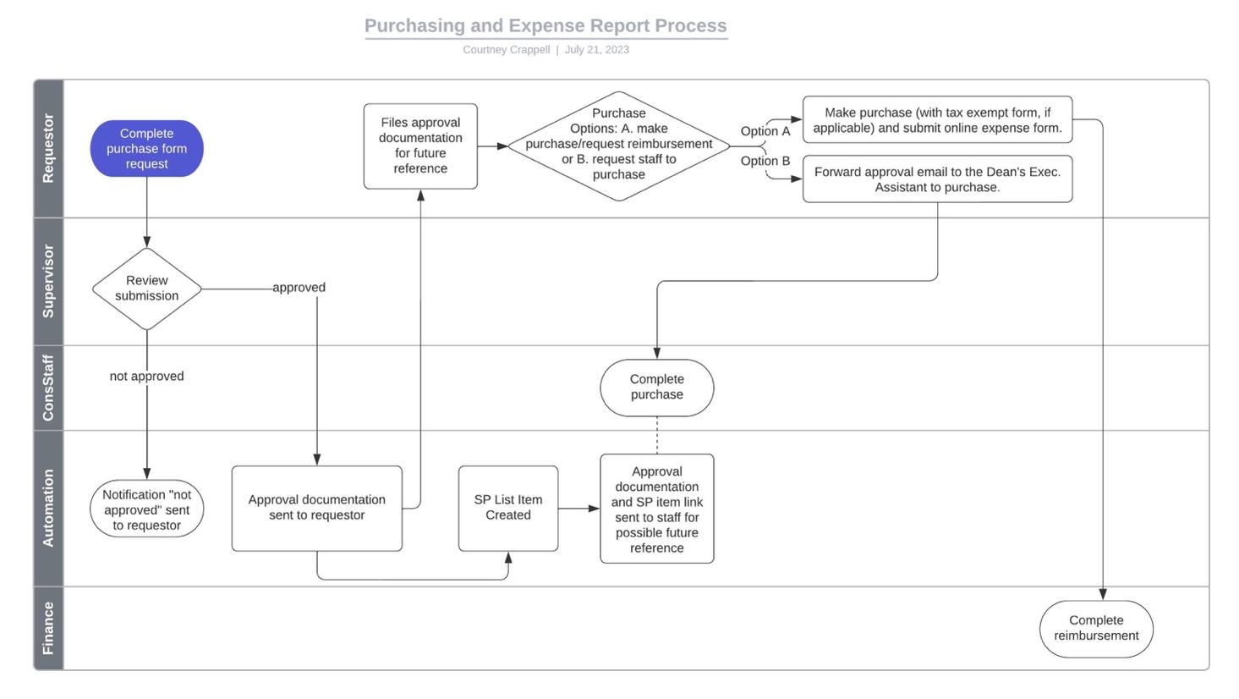
Hiring for Services: Planning for Guest Artists/Vendors
Begin this process immediately once you are in receipt of a notification of financial award or allocation for hiring a Guest Artist/Vendor. At minimum, your request must be received 1 month before services are planned. The process is initiated by you as the “requestor” when you complete the “Hire a Vendor/Guest Artist” form here. (https://forms.office.com/Pages/ResponsePage.aspx?id=vv3-4-n3G0ClGjVeAbBaiVRjNDOl7hhCj2jnYnjRcQBUQjVUQ0Q0SUxBQk1ITE1DUVhCNUxFOERKSCQlQCN0PWcu)

The complete process is outlined in the workflow below. Please study these steps and note your role as “requestor.” (In the workflow, a guest artist is defined as the “Vendor.”)

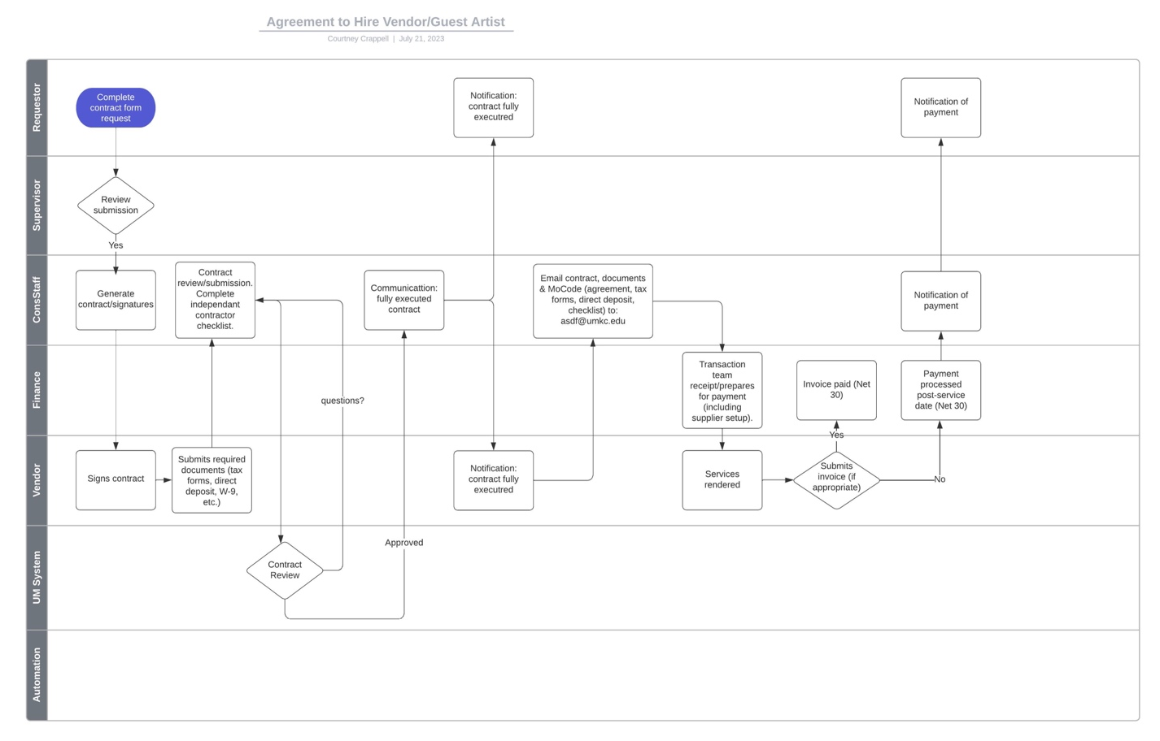

Music Purchases/Rentals
A budget has been created for large ensembles and chamber ensembles to purchase/rent music for performance during the academic year. There is a form for each as rentals typically require additional information. Faculty will begin by filling out the appropriate form. There is a minimum of 4 weeks advance of the required date for a music purchase, and a minimum of 6 weeks advance of the required date for music rentals. Select, and complete the appropriate form below.

Music Purchases:
Form here. (https://forms.office.com/Pages/ResponsePage.aspx?id=vv3-4-n3G0ClGjVeAbBaiVRjNDOl7hhCj2jnYnjRcQBUQjg4QTJSMFpHWU0yU01BV0s5Mzc4TUw1TSQlQCN0PWcu)

Music Rentals:
Form here. (https://forms.office.com/Pages/ResponsePage.aspx?id=vv3-4-n3G0ClGjVeAbBaiVRjNDOl7hhCj2jnYnjRcQBUODhWWUJPNzQyVFRBVklBUU5RNVZHVlNPSCQlQCN0PWcu)

